Title Title (Times New Roman, 14 pt, Bold, Center)

Author(s) name (Times New Roman, 12 pt, center)^{1,2}, Next Author^{1,2}, Corresponding Author¹

e-mail: xxxxx@xxxxx.xxx.xx

¹Affiliation(s) (Times New Roman, 10 pt, italic, center)
²Affiliation(s) (Times New Roman, 10 pt, italic, center)
Indicate the superscript number in front of the affiliations

Abstract (Times New Roman, 12 pt, justify, not exceed 250 words, justify, graphical abstract can be included but overall abstract pages should not be more than 2 pages)
(Example) Starch-based polymers and starch blends like thermoplastic starch (TPS) are among the most utilized polymers for commercially biodegradable materials. However, starch-based polymers and starch blends have some limitations, e.g., plasticizer leakage and starch retrogradation leading to poor mechanical properties and sticky surface after a certain period are the major points to obstruct the practical applications. Up to present, polymeric materials under covalent adaptable networks (CANs) of dynamic covalent bonds (DC) [1,2, and 3] are recognized as thermoset networks with thermoplastic performances.
To our idea, the introduction of dynamic crosslinks between starch and plasticizer is a good approach to maintain plasticizers in the starch chain via CANs resulting in a starch retrogradation retardance and reprocessability. Herin, we consider two types of DC approaches, i.e., (i) constructing DC via thermoreversible Diels-Alder (DA) reaction is considered (Scheme I). By simply modifying starch and glycerol with furan and maleimide, TPS with Diels-Alder dynamic covalent bonds (TPSDA) can be obtained, and (ii) combining TPS and vinylogous urethane bonds, by simply modifying TPS with acetoacetate group followed by the reaction with primary amines, TPS vinylogous urethane vitrimer (TPSV) can be obtained. The presentation will cover the detailed preparation of TPSDA and TPSV including the detailed analysis, properties, and performances.

Scheme I
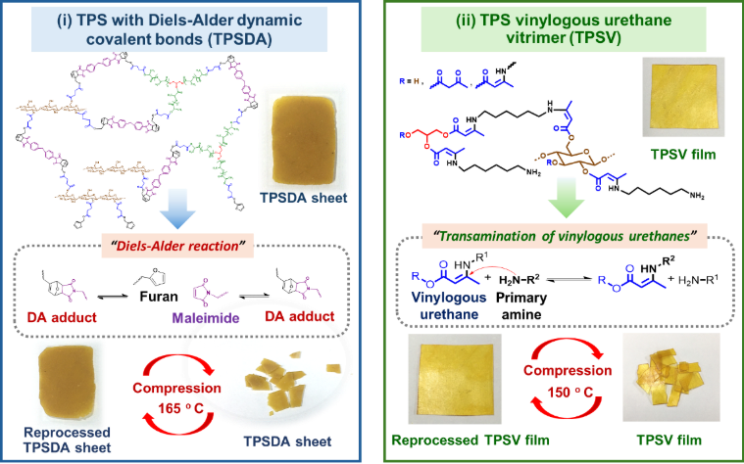

References 1) M. Damien, et al., Science 334, 965-968 (2011). 2) X. Li, et al. Polymer 200, 122532 (2020). 3) W. Denissen, et al., Adv. Funct. Mater., 25, 2451-2457 (2015)

Biography (For Plenary, Keynote, and Invited Speakers)

Name: ………………………  Title: ………………………  Affiliation: ………………………  Country: ………………………  Phone………………………  E-mail: ……………………… | Picture

Personal History:
………………………………………………………………………………………………………………………………………………………………………………………………………………………………………………………………………………………………………………………………………………………………………………………………………………………………………………………………………………………………………………………………………………………………………………………………………………………………………………………………………………………………………………………………………………………………………………………………………………………………………………………………………………………………………………………………………………………………………………………………………………………………………………………………………………………………………………………………………………………………………………………………………………………………………………………………………………………………………………………………………………………………………………………………………………………………….
Research Keyword (3-5 keywords use commas to separate each word):
Xxxxxx, Xxxxxx, Xxxxxx, Xxxxxx

